**A PRACTICAL LAB REPORT**

Submitted in the partial fulfilment for the Course of

**CSA0516 Database Management Systems for Network Security**

to the award of the degree of

**BACHELOR OF ENGINEERING**

**IN**

# **ARTIFICIAL INTELLIGENCE AND MEACHINE LEARNING**

**Submitted by**

**P. Surendra Kumar Reddy (192425224)**

**Under the Supervision of**

**DR. J. VELMURUGAN**

**DR. S. PANDIRAJ**



# **SIMATS ENGINEERING**

**Saveetha Institute of Medical and Technical Sciences**

**Chennai-602105**

**September-2025**

DDL Commands – CREATE, ALTER, DROP

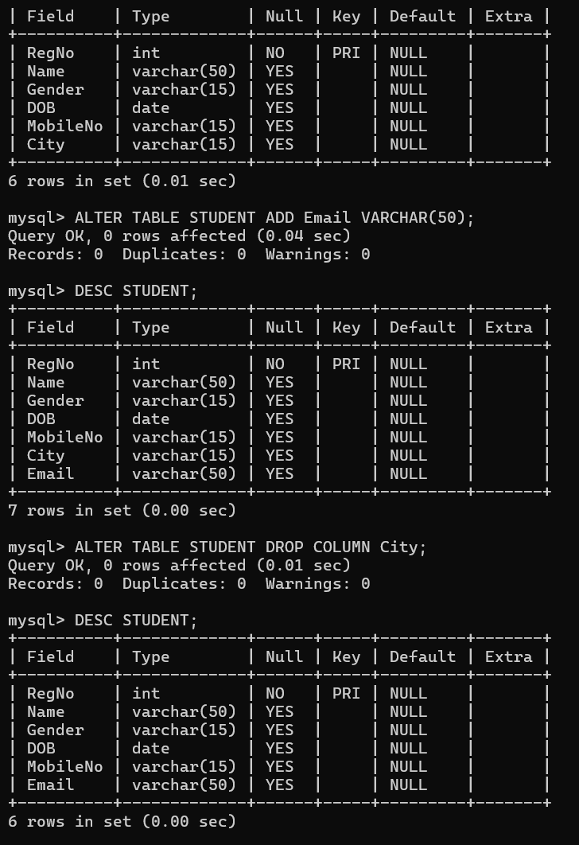

DDL Commands with Constraints – PRIMARY, FOREIGN

KEY, UNIQUE, CHECK

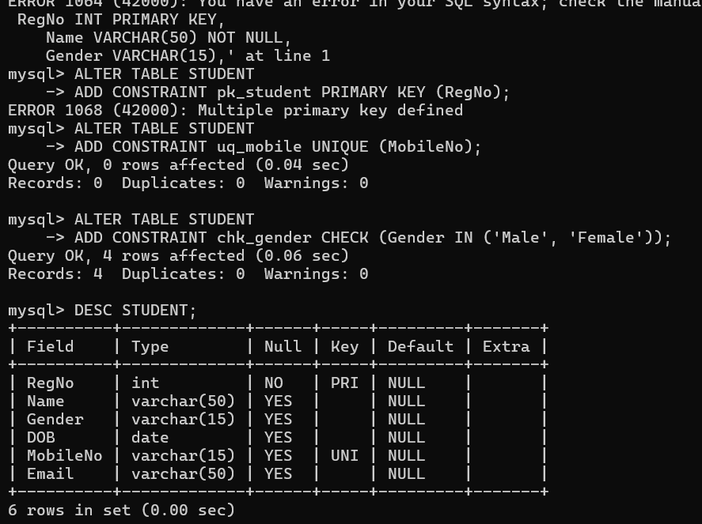DML Commands – INSERT, SELECT, UPDATE, DELETE

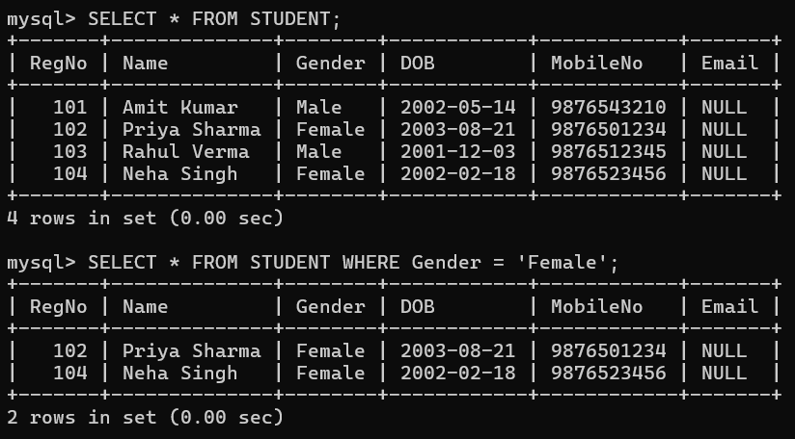SELECT with various clause – WHERE, pattern matching

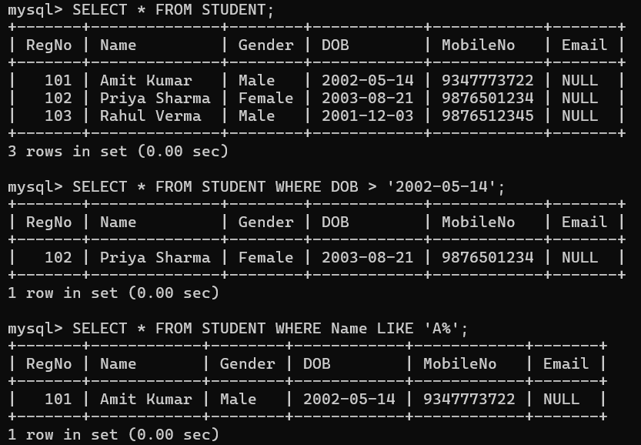

SELECT with various clause – BETWEEN, IN, Aggregate

Function

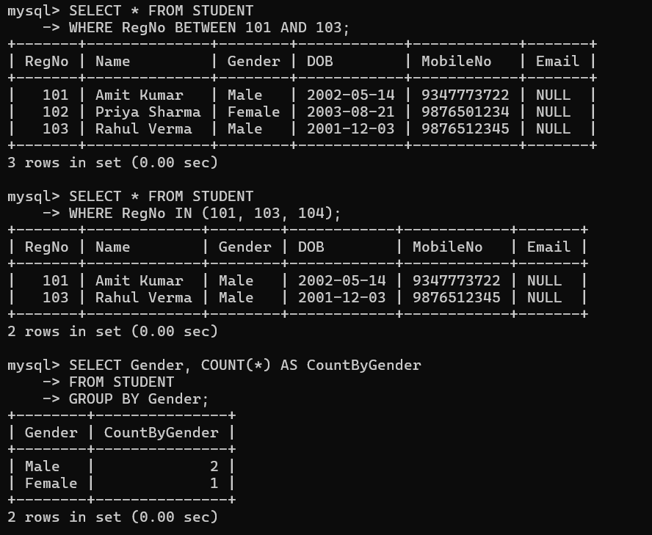

SELECT with various clause – GROUP BY, HAVING, ORDERBY

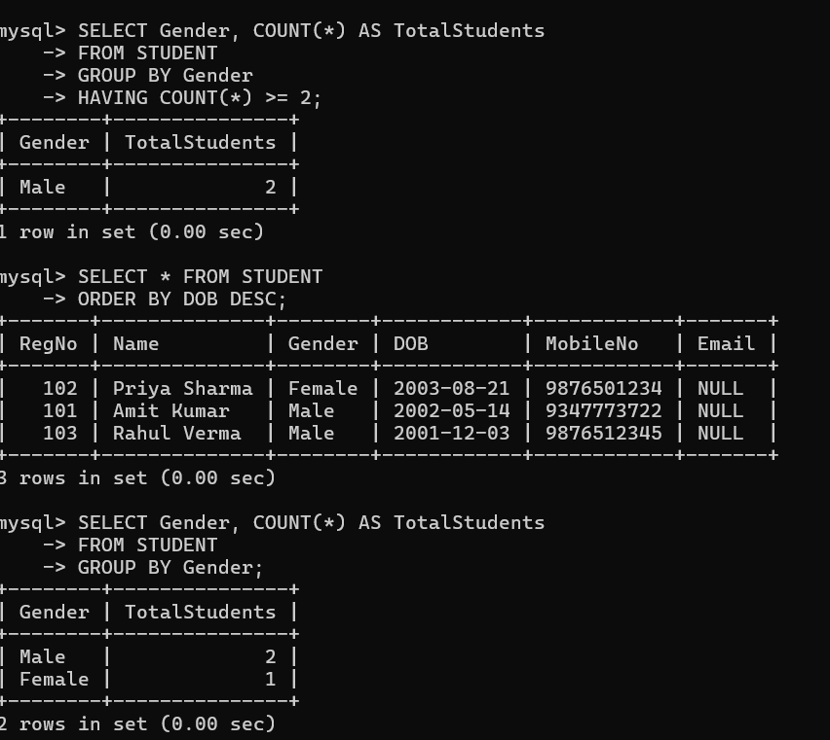

SubQuery& Correlated Query

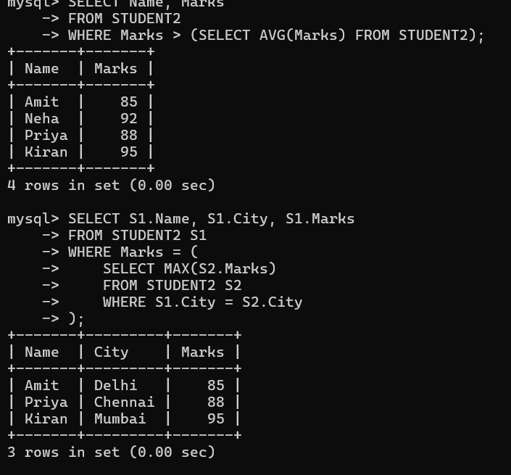

Joins – EquiJoin, InnerJoin, OuterJoin

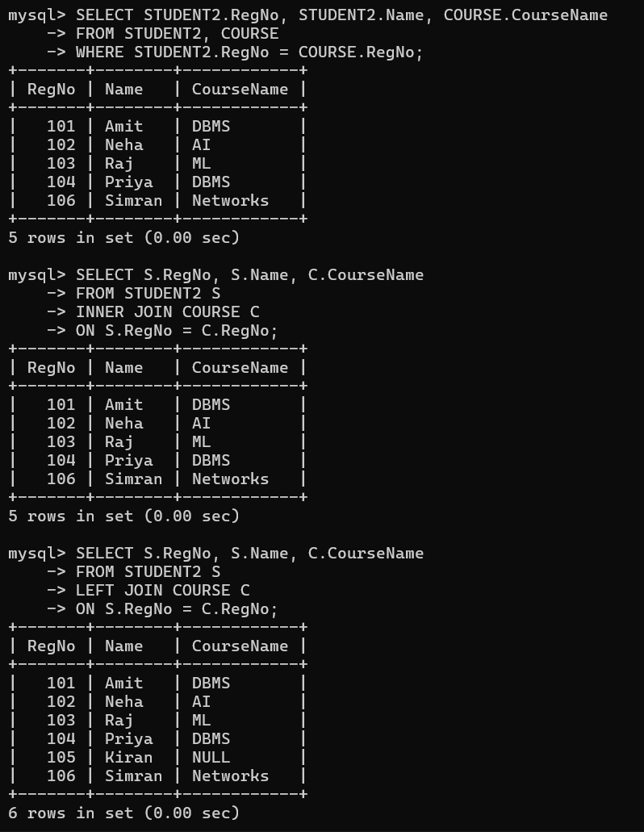

VIEW, INDEX, SEQUENCE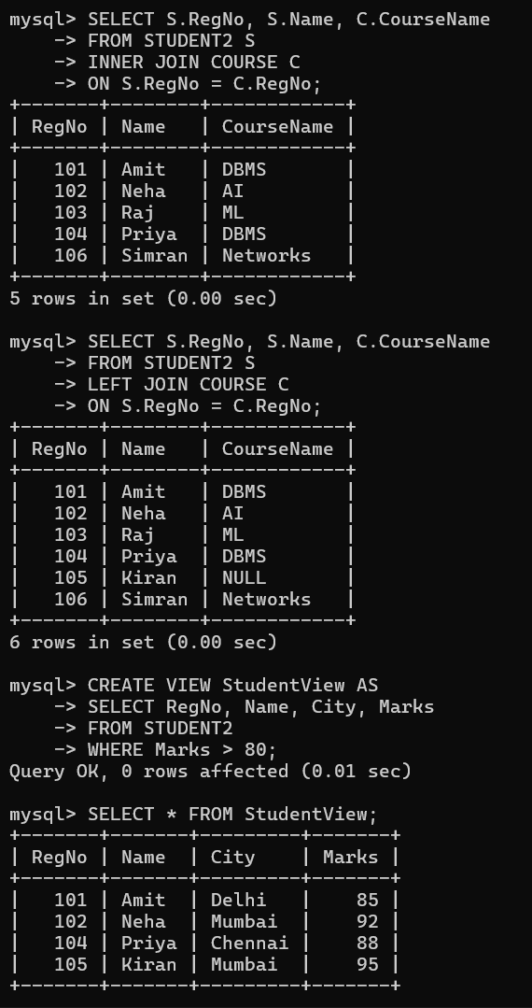E

Simple programming exercises using CASE, IF, ITERATE,

LEAVE, LOOP

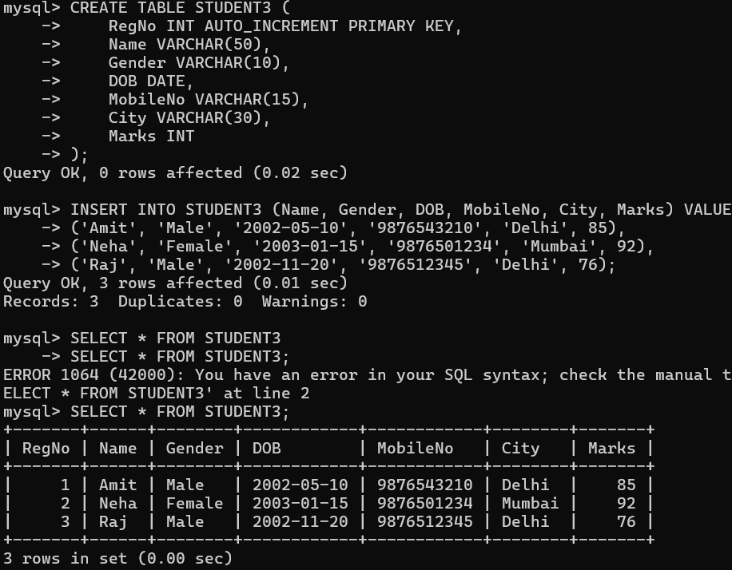

Simple programming exercises using REPEAT, WHILE



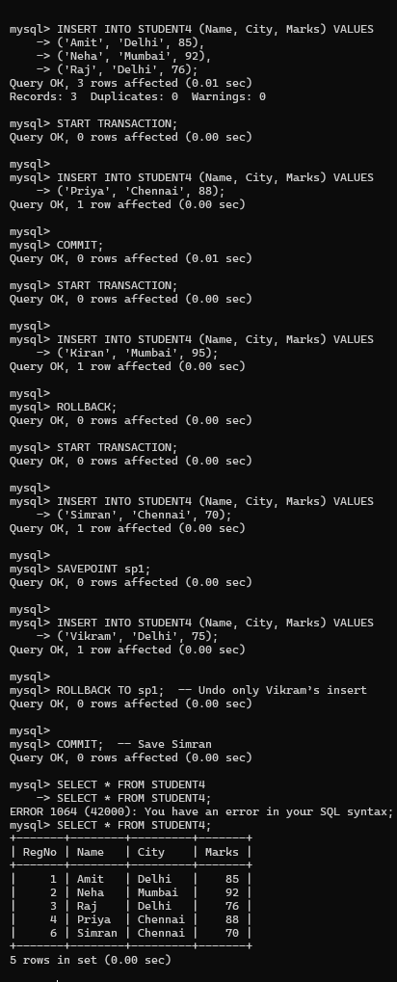TCL Commands – COMMIT, ROLLBACK, SAVEPOINT

DCL Commands – GRANT, REVOKE

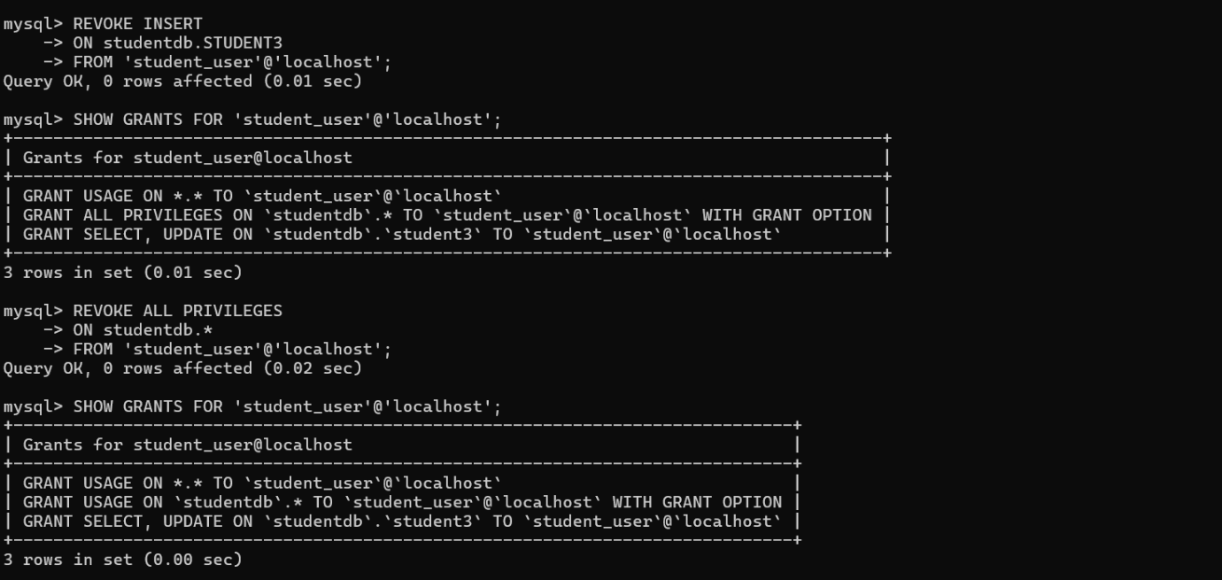

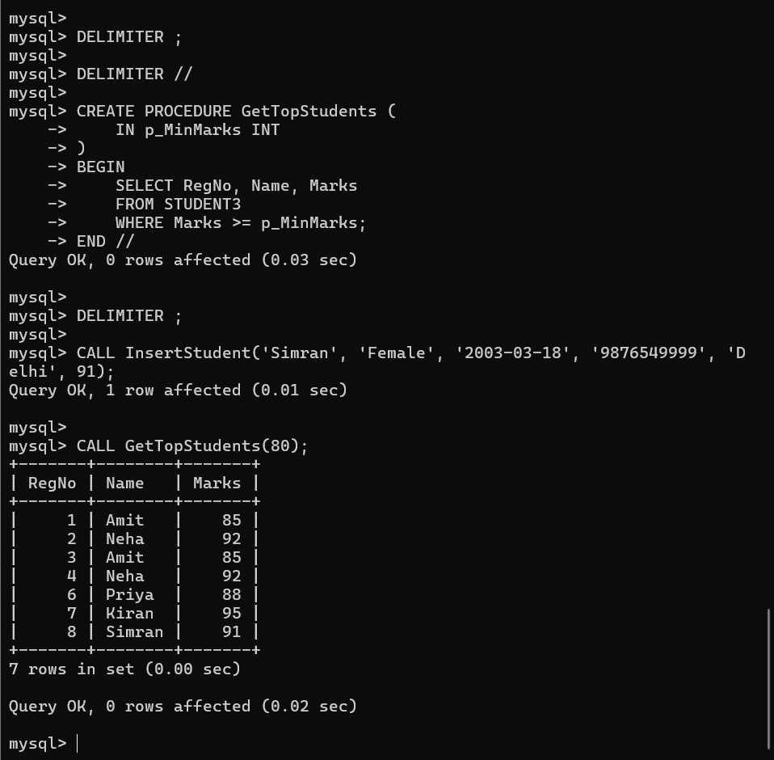Procedures

Function

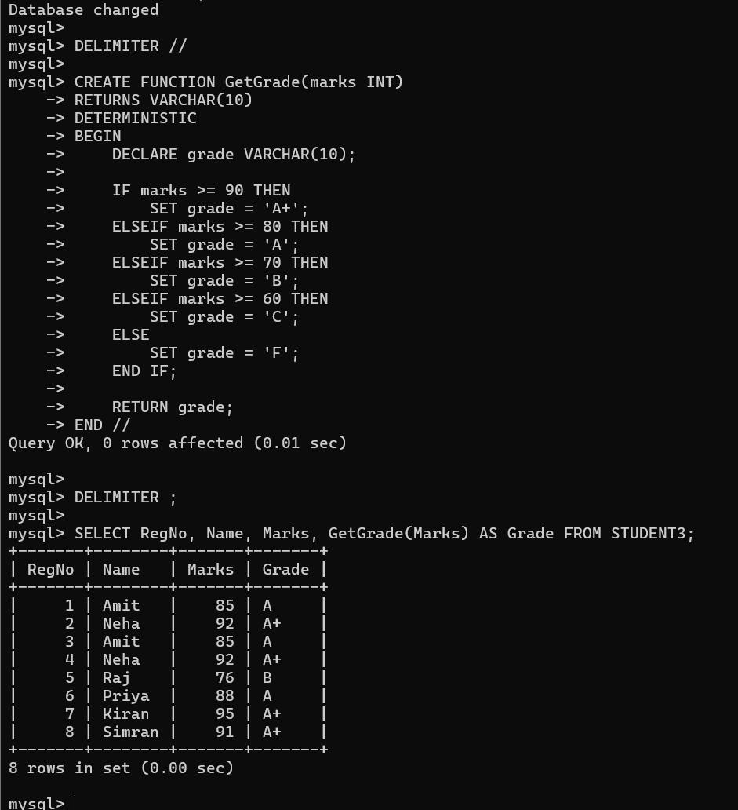

Cursors

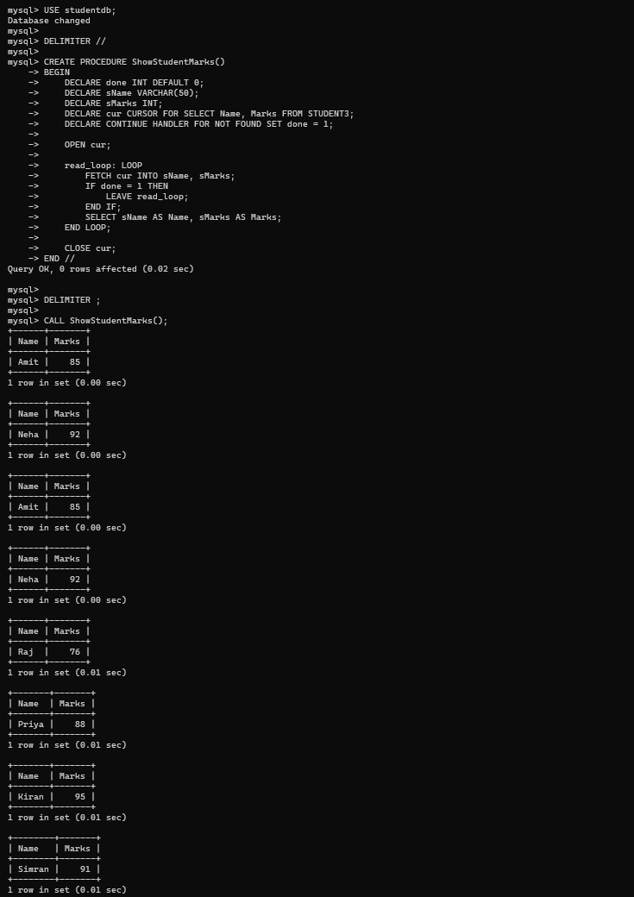

Triggers

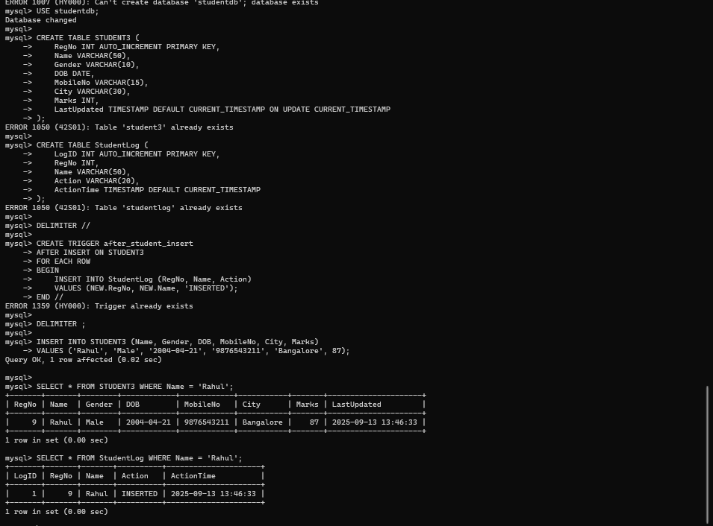

String Functions

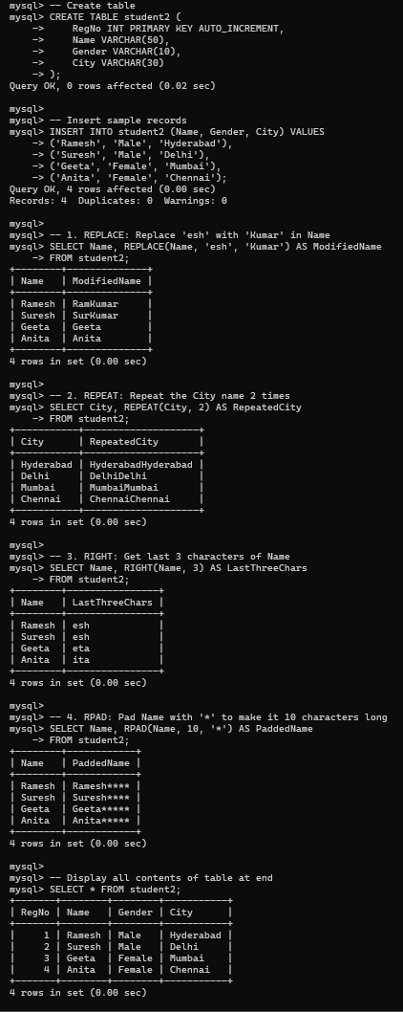

Database Connectivity – Using PhP& MySQL

